**Ref - https://keirsey.com/**

**KEIRSEY PERSONALITY TEST**

Keirsey transforms your understanding of people. We provide you with a unique perspective that brings clarity on who you are, what you do, who you love, and what difference you make. Keirsey offers an integrated system of solutions for your most important people opportunities and challenges.

Temperament is a configuration of observable personality traits, such as habits of communication, patterns of action, and sets of characteristic attitudes, values, and talents. It also encompasses personal needs, the kinds of contributions that individuals make in the workplace, and the roles they play in society. Each temperament has its own unique qualities and shortcomings, strengths and challenges. Dr. David Keirsey has identified humankind's four basic temperaments as the Artisan, the Guardian, the Idealist, and the Rational.

***Temperament Metrix***

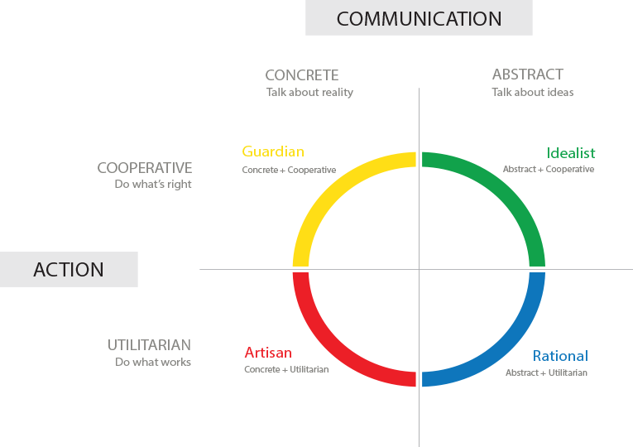

***Classification of Temperament***

